# SQL – WORKSHEET 3

**Refer the following ERD and ANSWER all the questions in this worksheet. You have to write the queries using mysql for the required Operation.**

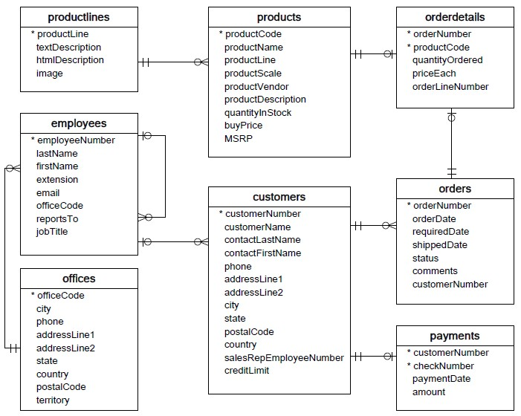

* **Customers**: stores customer’s data.
* **Products**: stores a list of scale model cars.
* **ProductLines**: stores a list of product line categories.
* **Orders**: stores sales orders placed by customers.
* **OrderDetails**: stores sales order line items for each sales order.
* **Payments**: stores payments made by customers based on their accounts.
* **Employees**: stores all employee information as well as the organization structure such as who reports to whom.
* **Offices**: stores sales office data.
  1. Write SQL query to create table **Customers.**

**ANSWER :** CREATE TABLE Customers (  
    customerNumber int,  
    customerName varchar(255),

customerLastName varchar(255),

customerFisrtName varchar(255),

phone int,

addressLine1 varchar(255),

addressLine2 varchar(255),

city varchar(255),

state varchar(255),

postalCode int,

country varchar(255),

salesRepEmployeeNumber int,

creditLimit int,

);

* 1. Write SQL query to create table **Orders.**

**ANSWER:** CREATE TABLE Orders (  
    orderNumber int,  
    orderDate DATE,

requiredDate DATE,

shippedDate DATE,

status varchar(255),

comments varchar(255),

customerNumber int,

);

* 1. Write SQL query to show all the columns data from the **Orders** Table.

**ANSWER**: SELECT orderNumber ,  
    orderDate,

requiredDate ,

shippedDate ,

status ,

comments ,

customerNumber

FROM Orders;

* 1. Write SQL query to show all the comments from the **Orders** Table.

**ANSWER**: SELECT comments FROM Orders;

* 1. Write a SQL query to show orderDate and Total number of orders placed on that date, from **Orders** table.

**ANSWER**: SELECT date(orderDate), COUNT(customerNumber) AS num_orders

FROM orders

GROUP BY date(orderDate)

* 1. Write a SQL query to show employeNumber, lastName, firstName of all the employees from **employees**

table.

**ANSWER**: CREATE TABLE employees (

employeNumber int,

lastName varchar(255),

firstName varchar(255),

);

SELECT employeNumber, lastName, firstName FROM employees ;

* 1. Write a SQL query to show all orderNumber, customerName of the person who placed the respective order.

**ANSWER**: SELECT a.customerName, b.orderNumber

FROM Customers a

LEFT OUTER JOIN Orders b

ON a.customerNumber = b.customerNumber ;

* 1. Write a SQL query to show name of all the customers in one column and customerName number in another column.

**ANSWER** : SELECT customerName, salesRepEmployeeNumber FROM Customers;

* 1. Write a SQL query to show Date in one column and total payment amount of the payments made on that date from the **payments** table.

**ANSWER**: SELECT date(paymentDate), SUM(amount) AS total_amount

FROM payments

GROUP BY date(paymentDate) ;

* 1. Write a SQL query to show all the products productName, MSRP, productDescription from the **products**

table.

**ANSWER**: SELECT productName, MSRP, productDescription FROM products **;**

* 1. Write a SQL query to print the productName, productDescription of the most ordered product.

**ANSWER**: SELECT productName , productDescription, SUM(quantityInStock) AS quantity

FROM products

GROUP BY productName

ORDER BY SUM(quantityInStock) DESC ;

* 1. Write a SQL query to print the city name where maximum number of orders were placed.

**ANSWER**: SELECT city,COUNT(customerNumber) AS no_of_orders

FROM Customers

WHERE no_of_orders = MAX(COUNT(customerNumber)) ;

* 1. Write a SQL query to get the name of the state having maximum number of customers.

**ANSWER**: SELECT state,COUNT(DISTINCT customerNumber) AS no_of_customers

FROM Customers

WHERE no_of_orders = MAX(COUNT(customerNumber)) ;

* 1. Write a SQL query to print the employee number in one column and Full name of the employee in the second column for all the employees.

**ANSWER**:SELECT CONCAT(firstName, ' ', lastName) AS whole_name FROM employees;

* 1. Write a SQL query to print the orderNumber, customer Name and total amount paid by the customer for that order (quantityOrdered × priceEach).

**ANSWER**:

SELECT (ordersdetail.quantityOrdered * ordersdetail.priceEach) AS total_amount , orderNumber, customerName

FROM Customers

JOIN Orders ON Orders.customerNumber = Customers.customerNumber

JOIN orderdetails ON orderdetails.orderNumber= Order.orderNumber ;

